Cointegration and ECM: EURUSD and USDCAD
Method 27 / Engle-Granger on log closes / one-lag ECM / Alpari D1 full available history

Study setup
Logical pair: PX=EURUSD , PY=USDCAD
Broker symbols: EURUSD_i , USDCAD_i
Snapshot: 2026-11-03_majors_alpari_D1
Timeframe: D1
Matched window: 1999-01-05 to 2026-11-02 (UTC bar dates)
Matched level count n: 7188
Dropped unfinished last bar dated 2026-11-03 UTC after a tick-volume check against the prior complete day.
ECM lags of deltas: 1
Complete matched rows (Excel): EURUSD-USDCAD_Coint_D1.xlsx
Complete matched rows (HTML table): EURUSD-USDCAD_Coint_D1_data.html

Method carried forward
Engle-Granger cointegration works on log price levels, not returns. For each unordered pair, PX is the left leg and PY the right leg. Step one: OLS ln(PY) = alpha + beta * ln(PX) + e. Step two: statsmodels Engle-Granger coint test on (ln(PY), ln(PX)). Error-correction: delta ln(PY)_t = c + kappa * e_{t-1} + lagged delta ln(PY) and delta ln(PX) (one lag each) + u_t. Headline is the Engle-Granger p-value (lower = stronger evidence of a stationary spread) with kappa and beta reported alongside. Same-sample Pearson r of log returns is a side check only. beta is not an automatic lot-size hedge. This is not a trading signal.

Results (headline)
alpha: 0.374605
beta: -0.929008
Engle-Granger t: -3.600037
Engle-Granger p: 0.024499
5% critical value: -3.336980
ECM kappa: -0.002654
kappa t-stat: -2.8564
ECM R^2: 0.003118
spread std: 0.065250
Pearson r (returns): -0.456626

Conclusion
Engle-Granger for PY=USDCAD on PX=EURUSD: beta=-0.9290, alpha=0.3746, coint_t=-3.6000, p=0.0245 (5% crit=-3.3370). ECM kappa=-0.0027 (t=-2.86). Pearson r of returns = -0.4566. beta is not a lot-size hedge. Not a trading signal.

Charts
Daily closes

Engle-Granger residual spread
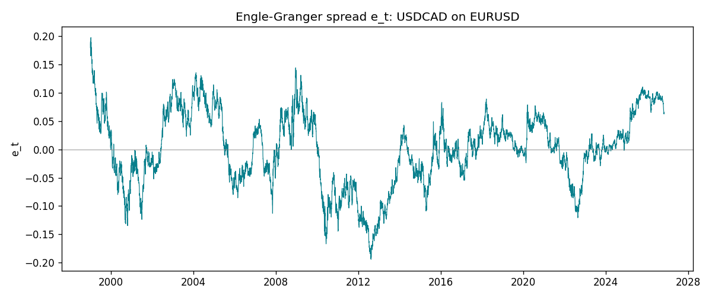
Daily log returns
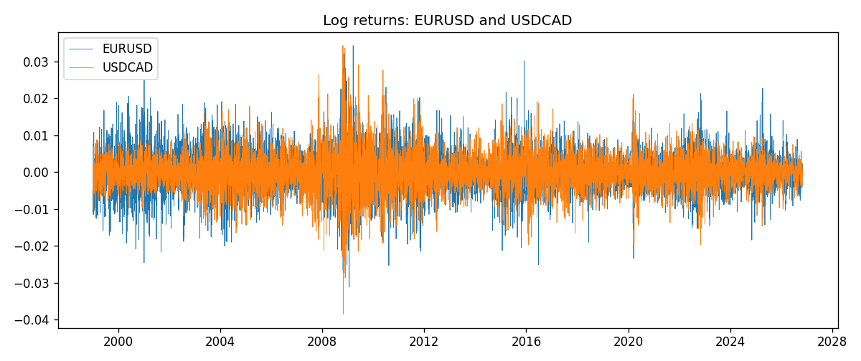

Data report
Matched rows are in the sibling Excel workbook named EURUSD-USDCAD_Coint_D1.xlsx. Embedding all rows as a Word table is impractical; this file holds column summaries and the first and last 15 matched rows.
Column summaries
column | count | mean | std | min | 25% | 50% | 75% | max
EURUSD_open | 7188 | 1.1814345 | 0.15078289 | 0.8272 | 1.086195 | 1.16617 | 1.2939425 | 1.5995
USDCAD_open | 7188 | 1.2667783 | 0.16890181 | 0.9168 | 1.1183975 | 1.298465 | 1.37211 | 1.6183
EURUSD_high | 7188 | 1.1865652 | 0.15138546 | 0.8326 | 1.0902775 | 1.17128 | 1.2993025 | 1.6038
USDCAD_high | 7188 | 1.2716763 | 0.16885945 | 0.9336 | 1.12285 | 1.30387 | 1.37649 | 1.619
EURUSD_low | 7188 | 1.1764236 | 0.15010221 | 0.8227 | 1.0820675 | 1.16257 | 1.2883725 | 1.5865
USDCAD_low | 7188 | 1.26222 | 0.16893673 | 0.9056 | 1.114065 | 1.293535 | 1.367805 | 1.6102
EURUSD_close | 7188 | 1.181473 | 0.1507571 | 0.8267 | 1.0860725 | 1.166175 | 1.2939575 | 1.5997
USDCAD_close | 7188 | 1.2667932 | 0.16887388 | 0.916 | 1.118295 | 1.29844 | 1.372365 | 1.6137
EURUSD_tick_volume | 7188 | 103177.84 | 173518.96 | 218 | 9407.75 | 52764 | 99553.25 | 1471626
USDCAD_tick_volume | 7188 | 81016.727 | 147303.02 | 37 | 5545 | 40941.5 | 71627 | 1410818
EURUSD_spread | 7188 | 19.349471 | 16.556644 | 0 | 8 | 12 | 30 | 50
USDCAD_spread | 7188 | 23.444073 | 18.266035 | 0 | 9 | 17 | 40 | 60
EURUSD_real_volume | 7188 | 4.031926e+10 | 1.6689501e+11 | 0 | 0 | 0 | 0 | 3.6149665e+12
USDCAD_real_volume | 7188 | 1.8376704e+10 | 9.6688094e+10 | 0 | 0 | 0 | 0 | 2.5751613e+12
EURUSD_log_price | 7188 | 0.15852414 | 0.12898319 | -0.19031341 | 0.08256798 | 0.15372916 | 0.25770535 | 0.46981611
USDCAD_log_price | 7188 | 0.22733513 | 0.13644038 | -0.08773891 | 0.1118052 | 0.26116354 | 0.31653553 | 0.47852968
EURUSD_log_return | 7188 | -7.59e-06 | 0.00580128 | -0.03123819 | -0.0032472 | 0 | 0.00325412 | 0.03433183
USDCAD_log_return | 7188 | -1.518e-05 | 0.00514306 | -0.03859748 | -0.00283637 | 4.741e-05 | 0.00272353 | 0.03436319
spread_e | 7188 | -0 | 0.06525023 | -0.19417926 | -0.04254443 | 0.00278796 | 0.0495389 | 0.19709959
ecm_fitted | 7187 | -1.378e-05 | 0.00028714 | -0.00152892 | -0.00019211 | -2.351e-05 | 0.00015479 | 0.00143052
First 15 matched rows (selected columns)
time | EURUSD_log_price | USDCAD_log_price | spread_e | EURUSD_log_return | USDCAD_log_return
1999-01-05 | 0.16194877 | 0.41363167 | 0.18947804 | -0.0048360507 | -0.010131666
1999-01-06 | 0.1504008 | 0.41330099 | 0.17841921 | -0.011547966 | -0.0003306769
1999-01-07 | 0.15802886 | 0.4148212 | 0.18702595 | 0.0076280636 | 0.0015202092
1999-01-08 | 0.14712606 | 0.41277168 | 0.17484764 | -0.010902799 | -0.0020495197
1999-01-11 | 0.14002278 | 0.40925791 | 0.16473485 | -0.007103287 | -0.0035137769
1999-01-12 | 0.14453315 | 0.41587738 | 0.1755445 | 0.0045103728 | 0.0066194721
1999-01-13 | 0.1553785 | 0.4204194 | 0.19016193 | 0.010845346 | 0.0045420214
1999-01-14 | 0.1553785 | 0.42735705 | 0.19709959 | 0 | 0.0069376546
1999-01-15 | 0.14522525 | 0.42166649 | 0.18197657 | -0.010153245 | -0.0056905671
1999-01-18 | 0.14885095 | 0.42264993 | 0.18632832 | 0.0036256946 | 0.00098344542
1999-01-19 | 0.14867859 | 0.42539845 | 0.18891671 | -0.00017235436 | 0.002748513
1999-01-20 | 0.14548467 | 0.41943376 | 0.17998484 | -0.0031939256 | -0.0059646885
1999-01-21 | 0.14850621 | 0.41515138 | 0.1785095 | 0.0030215416 | -0.0042823796
1999-01-22 | 0.14729869 | 0.41765715 | 0.17989347 | -0.0012075213 | 0.0025057712
1999-01-25 | 0.14427349 | 0.41851295 | 0.17793884 | -0.0030251979 | 0.00085579808
Last 15 matched rows (selected columns)
time | EURUSD_log_price | USDCAD_log_price | spread_e | EURUSD_log_return | USDCAD_log_return
2026-10-13 | 0.11301614 | 0.3516423 | 0.082029846 | 0.0037402957 | -0.0046395653
2026-10-14 | 0.10925791 | 0.35316078 | 0.080056897 | -0.0037582255 | 0.0015184751
2026-10-15 | 0.11486322 | 0.34955063 | 0.081654128 | 0.0056053107 | -0.0036101503
2026-10-16 | 0.11663571 | 0.34611842 | 0.079868579 | 0.0017724895 | -0.0034322068
2026-10-19 | 0.11409625 | 0.34423489 | 0.075625863 | -0.0025394633 | -0.0018835331
2026-10-20 | 0.11648442 | 0.34052829 | 0.07413789 | 0.0023881672 | -0.0037066008
2026-10-21 | 0.11616395 | 0.33968137 | 0.072993255 | -0.00032046717 | -0.00084691787
2026-10-22 | 0.11456899 | 0.33705064 | 0.068880796 | -0.0015949606 | -0.0026307268
2026-10-23 | 0.11323047 | 0.3370792 | 0.067665854 | -0.001338521 | 2.85545e-05
2026-10-26 | 0.11095981 | 0.3371363 | 0.065613502 | -0.0022706559 | 5.7106554e-05
2026-10-27 | 0.10680747 | 0.33967425 | 0.064293887 | -0.004152342 | 0.0025379458
2026-10-28 | 0.10903376 | 0.33583632 | 0.062524204 | 0.0022262927 | -0.0038379274
2026-10-29 | 0.1112909 | 0.33572196 | 0.064506737 | 0.0022571351 | -0.00011436495
2026-10-30 | 0.11014505 | 0.33469208 | 0.062412364 | -0.0011458446 | -0.0010298736
2026-11-02 | 0.11226562 | 0.33530727 | 0.064997581 | 0.002120569 | 0.00061519094

